TCS and Infosys interview questions:

Tcs interview questions

Incremental load – cdc?

Scd type 1 n type 2 difference

A
1
1
1
1
Null

B
1
1
2
3
4

- Inner Join
  - Matches only common values.
  - Here, value 1 appears 4 times in A and 2 times in B.
  - So total matches = $4×2=8$.
  - NULL in A doesn’t match anything in B.
- Left Join
  - All rows from A, plus matches from B.
  - For the 4 rows of 1 in A → 8 matches (same as inner).
  - For the NULL in A → 1 row with NULLs for B’s columns.
  - Total = 9 rows.
- Right Join
  - All rows from B, plus matches from A.
  - For 1 in B (2 rows) → 8 matches (same as inner).
  - For 2, 3, 4 in B → each gets 1 row with NULLs for A’s columns.
  - Total = 11 rows.
- Full Outer Join
  - All rows from both tables.
  - Includes the 8 matches for 1.
  - Plus 1 row for NULL in A.
  - Plus 3 rows for 2, 3, 4 in B.
  - Total = 12 rows.

Md5 how you will do and where you will give expression?
Md5 will take char and string as an output so if there is decimal yu need to change as to_char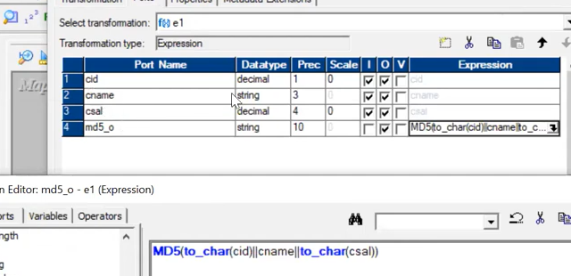

Soft delete n hard delete
• Type 1 → Hard delete is natural (row removed, no history).
• Type 2 → Soft delete is standard (inactive flag/end date). Hard delete breaks history.
• Type 3 → Usually a status update. Hard delete is possible but reduces it to Type 1 behavior.
Indirect file – multiple src files – sessiin – src – change as indirect instead of direct
Json file? How you are getting src flat file and database? Json?
Scd type 2 transformations and expressions write it? - delete
How many targets?

Persistent can be used in which transformations?
lookup, joiner, aggregator,Rank
What transformations you have used?
2nd highest salary - SELECT MAX(Salary) AS SecondHighest
FROM Employees
WHERE Salary < (SELECT MAX(Salary) FROM Employees);

If a job is running more than 30 mints what you will do? Deadlock? Except that?
🛑 Deadlock vs Performance
- Deadlock
  - Two processes are waiting on each other’s resources.
  - Symptoms: job hangs indefinitely, logs show lock contention.
  - Fix: kill one session, redesign to avoid circular locks (e.g., stagger updates, use smaller commits).
- Performance Issue
  - Job is running, but very slowly.
  - Causes: large data volume, inefficient queries, poor indexing, bad joins, lack of partitioning.
  - Fix: tune SQL, add indexes, optimize transformations, use partitioning, increase cache size.

🔗 Poor Join Example (Cartesian Product)
sql
SELECT e.EmployeeID, e.Name, d.DepartmentName
FROM Employees e, Departments d;
- ❌ Problem: No ON condition.
- Result: Every employee is joined with every department → Cartesian join.
- If you have 1,000 employees and 50 departments, this produces 50,000 rows instead of the actual matches.

Performance issue how you will fix it?

Cache – Meaning
- Cache = Temporary memory storage used by transformations (Lookup, Joiner, Aggregator, Rank).
- Types:
  - Index Cache → Stores key values for fast lookup.
  - Data Cache → Stores actual row data.
  - Persistent Cache → Saves cache to disk for reuse across sessions.
- Benefit: reduces repeated database hits, speeds up processing.
🔎 Filter vs Router Transformation
- Filter
  - Removes rows that don’t meet the condition.
  - Only one output path (rows that pass the filter).
  - Example: Salary > 50000.
- Router
  - Routes rows into multiple output groups based on conditions.
  - Each group can have its own condition.
  - Example:
    - Group 1 → Salary > 100000
    - Group 2 → Salary BETWEEN 50000 AND 100000
    - Group 3 → Salary < 50000.

Filter router difference

What's the advantage of router?

Unconnected lookup advantage and disadvantage
Do you know about index and how you will create it?

How many enhancements you will get?

Where you're loading data? Data warehousing? Where n what it's
End to end what you're doing. Business details? Complex mapping that you handled? Dynamic file loading..
What will you do in ur project? How you're using td and postgresql in ur project. Why you went onsite?
Why you moved from developer to production? Now why you're coming back again? What if give support role to you again?

Why used GitHub, Jenkins? Complex mapping that you handled?
Join 2 tables dept wise highest 2 salary
Row num, rank, dense rank
Perf issue how you will handle
What issues you faced in production?

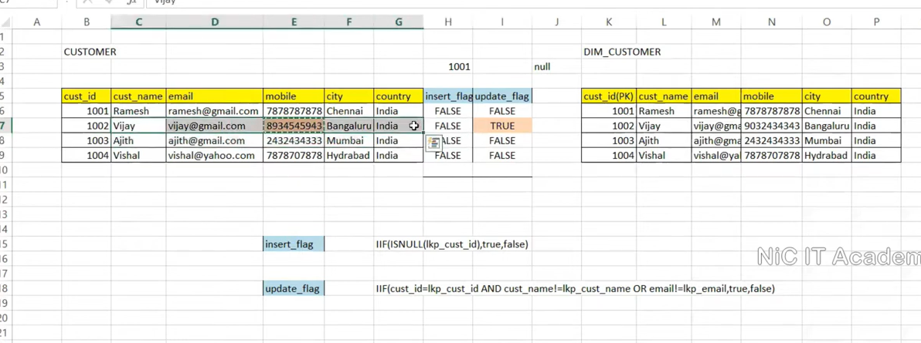
Type 3 - dd_update in update strategy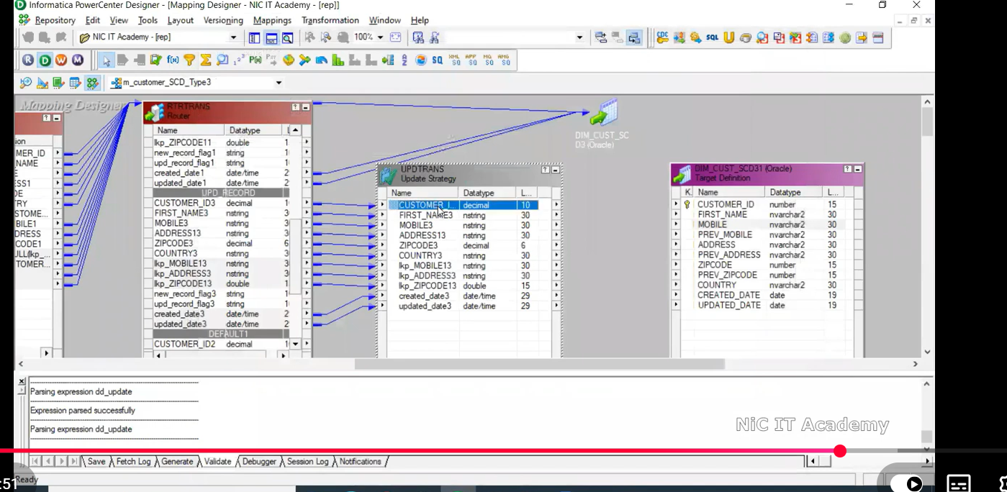 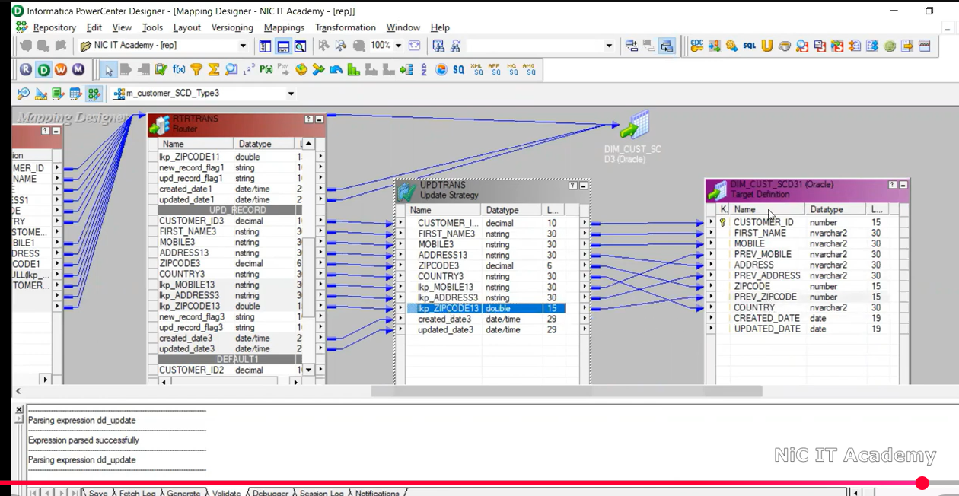 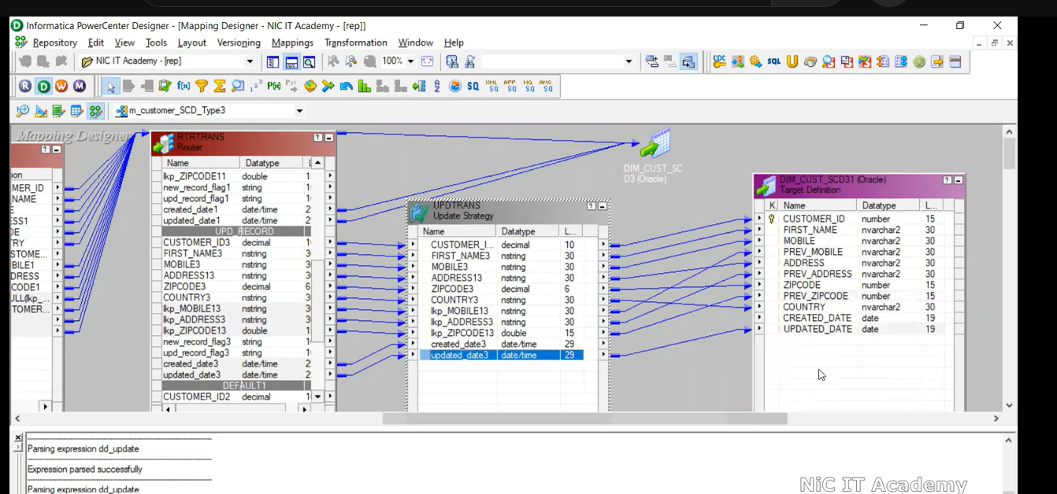

Md5 – can be done in scd type 1 and scd type 2